NOMINATION FORM FOR FAOBMB EDUCATION CHAIR  Date:  Email to phillip.nagley@monash.edu or send to:  Professor Phillip Nagley  Secretary-General of FAOBMB  Department of Biochemistry and Molecular Biology  Building 77  Monash University  Clayton, VIC 3800  Australia | 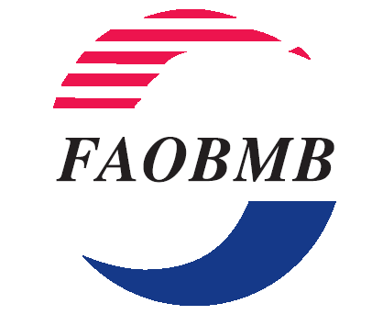

I nominate …………………………………………………………..for the position of:
Chair of FAOBMB Education Committee, to serve a three-year term during 2018 through to 2020.

Signature of Nominator:…………………………………Name of Nominator:………………………………………

Name of Nominator’s FAOBMB Member Society or Group:……………………………………………………..

I second the above nomination.

Signature of Seconder:………………………………….Name of Seconder:…………………………………….

Name of Seconder’s FAOBMB Member Society or Group:…………………………………………………..

I consent to serve as the Chair of FAOBMB Education Committee for the term of office stated above, if elected:

Signature of Nominee:…………………………………………

Name of Nominee:………………………………………………

Member of (name of FAOBMB Society or Group):………………………….......................................

Please include a brief biographical sketch of the nominee (up to one A4 page).

CLOSING DATE FOR RECEIPT OF NOMINATIONS BY SECRETARY-GENERAL: 24 JULY, 2017.

