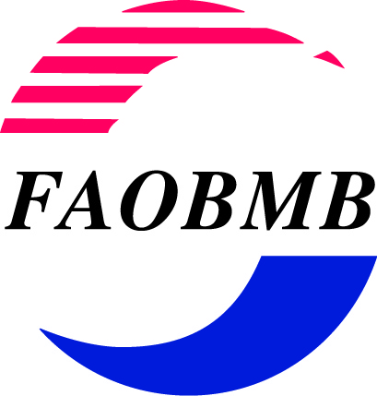 APPLICATION FORM

Young Scientist Award for 24th IUBMB-15th FAOBMB Congress, Seoul, Korea
4-9 June, 2018.

Name of Applicant: Dr ……………………………………

Gender: MALE _____ FEMALE _____ [Check the appropriate one with X]

Position:

Address of Applicant: (Normally this will be your institutional or office address)

Email address:

Membership of FAOBMB Constituent Society: (Indicate the Constituent Society of FAOBMB in your country/region of residence which you are a member). Please refer to the Guidelines.

Provide membership Number (if available) ………………………
You must provide, as an attachment, a statement of certification of your valid membership confirmed by the Secretary or other responsible officer of the Constituent Society

Date of Birth:

Applicants must be no more than 35 years of age at the closing date for application:
(1 December, 2017). Your date of birth must not be earlier than 1 December, 1982.

Proof of Age: (Certification by the Head of your Institution or Department is required)

I certify on the basis of official documentation which I have seen (e.g. passport, birth
certificate or driver’s licence) that the date of birth of the applicant Dr………………………

is ………………….., as shown above.
(DD/Month/Year)

Signed:

Name and Position:
Brief Synopsis of Your Research Interests and Career Goals: (no more than one page)
Attachments required:

- List of Publications in International Journals *

- Full list of publications
- Highlighted list of top five publications

Please provide extra information on your top five publications, in a separate list.
In this list, for each of the five publications, you should list the impact factor (IF) of the journal, the significance of the outcomes of this work to the field, and your role and contribution to the work described

* Follow the style used in the Example of Publication list on Page 3 of the Guidelines.
- The Abstract that you have submitted or plan to submit for presentation at the Congress.
- Your Curriculum Vitae.
- Letters of recommendation from two referees.
- Certification of your valid current membership of the Constituent Society.
This statement must be provided by the Secretary or other responsible officer of the Constituent Member of FAOBMB. A list of Constituent Member societies of FAOBMB is provided on the FAOBMB webpage at: www.faobmb.com
Submission methods: You can apply in either of two ways:

- by sending an email with a PDF file of the application (plus attachments) to the Secretary General of FAOBMB, Professor Phillip Nagley:
phillip.nagley@monash.edu

This is the preferred method. In this case the complete application must be in a single PDF file, comprising the completed application form plus all attachments, including the two letters of recommendation.
(File name: 2018_YSA_APPLICANT SURNAME.pdf)

- by sending a hard copy of the application form and supporting documents to:

Professor Phillip Nagley
Department of Biochemistry and Molecular Biology
Building 77
Monash University,
Clayton, Victoria 3800,
Australia

Closing Date: Applications must be received by 1 December, 2017
(Australian Eastern Summer Time, GMT + 11).

Applicants will be notified by email of the decision of the FAOBMB Award Committee before 1 February, 2018.

