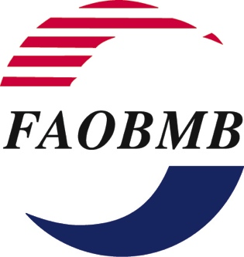APPLICATION FORM

Young Scientist Awards For 2024
17th FAOBMB Congress, Melbourne, Australia

Name of Applicant: Dr. .......................................................................................

Gender: MALE _____ FEMALE _____ [Check the appropriate one with X]

Position:

Address of Applicant: (Normally this will be your institutional or office address)

Email address:

Membership of FAOBMB Constituent Society: (Indicate the Constituent Society of FAOBMB in your country/region of residence which you are a member). Please refer to the Guidelines.

Provide membership Number (if available) ………………………
You must provide, as an attachment, a statement of certification of your valid membership confirmed by the Secretary or other responsible officer of the Constituent Society

Date of Birth:

Applicants must be no more than 35 years of age at the closing date for application:
(15 March 2024). Your date of birth must not be earlier than 16 March 1989.

Proof of Age: (Certification by the Head of your Institution or Department is required)

I certify based on official documentation which I have seen (e.g. passport, birth
certificate or driver’s licence) that the date of birth of the applicant Dr. ………………………

is …………………......................., as shown above.
(DD/Month/Year)

Signed:

Name and Position:
Brief Synopsis of Your Research Interests and Career Goals: (no more than one page)
Attachments required:

- List of Publications in International Journals *

- Full list of publications
- Highlighted list of top five publications

Please provide extra information on your top five publications, in a separate list.
In this list, for each of the five publications, you should list the impact factor (IF) of the journal, the significance of the outcomes of this work to the field, and your role and contribution to the work described.

* Follow the style used in the Example of Publication list on Page 3 of the Guidelines.
- The Abstract that you have submitted or plan to submit for presentation at the Congress.
- Your Curriculum Vitae.
- Letters of recommendation from two referees.
- Certification of your valid current membership of the Constituent Society.
This statement must be provided by the Secretary or other responsible officer of the Constituent Member of FAOBMB. A list of Constituent Member societies of FAOBMB is provided on the FAOBMB webpage at: www.faobmb.com

Submission method:

- Please send an email with a single PDF file of the application (including the attachments listed above) with the two letters of recommendation to the Secretary General of FAOBMB, Professor Sheila Nathan:
sheilanathan2023@gmail.com

(File name: 2024_FAOBMB YOUNG SCIENTIST AWARD_APPLICANT SURNAME.pdf)

Closing Date: Applications must be received by 1700 hrs (Malaysian Standard Time GMT +8) on 15 March 2024.

Applications received after the deadline stipulated above will not be processed.

Applicants will be notified by email of the decision of the FAOBMB Award Committee before 1 May 2024.

